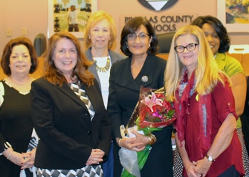

The Florida Association of Partners in Education (FAPE) named Michelle Roberge as the 2016 Adele Graham Award recipient at its recent conference held in Orlando.

The district school board recognized Michelle’s accomplishment at this week’s board meeting.

FAPE is a non-profit professional organization dedicated to enhancing student learning by building and maintaining effective community and school partnerships. The prestigious award is given in honor of the late Adele Graham, former Governor Bob Graham’s wife, for her dedication to community outreach and building partnerships for the betterment of student success.

For the last 15 years, Michelle has worked as the Volunteer Area Coordinator for the district. She has been a member of FAPE for the more than 15 years and for the past 2 years, she has served as the president. Under her leadership, she has provided innovative tools and strategies to districts across the state to increase school partnerships and enhance student success.

