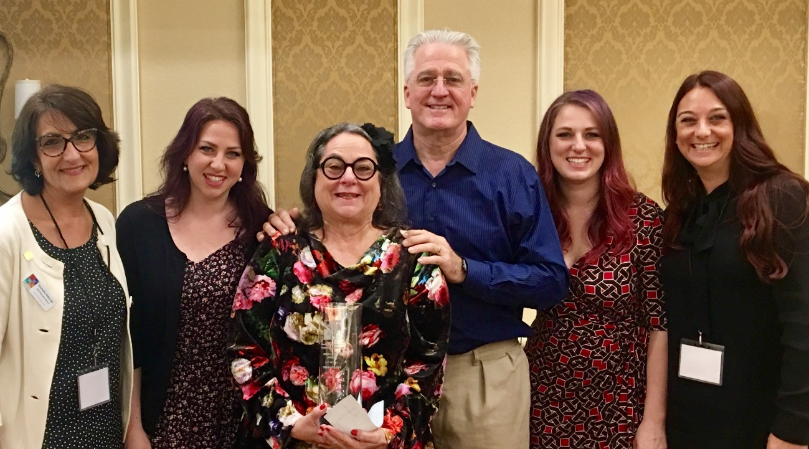
Left to Right: Michelle Roberge, Past President, FAPE, Pinellas County; Marissa McGehe, Daughter; Debi Elfen, Regional Representative FAPE, Palm Beach County; Dave McGehe, Husband; Shaina Adams, Daughter and
Misa Mills, FAPE President, Seminole County

Debi Elfen is the Volunteer Program Coordinator for the School District of Palm Beach County. She has worked for the district for over 15 years and is in the Office of Engagement of the Department of Communications and Engagement. Palm Beach County has 187 schools making it the 5th largest district in the state and 11th largest in the nation. There are over 42,000 volunteers and over 1,200 business partners. Debi has served as the Vice-President of Business Partnerships and is currently the Regional Representative for Region 5 for the Florida Association of Partners in Education (FAPE).

